Authors’ Names: Nigel B. Nkomo, R2310180M and Jubilee M. Chiangwa, R239588J

Supervisor’s Name: Mr M. Giyane

Course Title: HCSE236, Applied Project

Date: 18 January 2025

**Chapter 1: Introduction**

1.1 Introduction

This chapter sets the foundation for the research paper by introducing the problem, the scholarly context, and the proposed solution.

The method employed in this research follows the Test-A-Theory approach. This method involves “the use of an example or data set to evaluate (and potentially improve or disprove) a general philosophical or theoretical idea” [4]. In this particular case, this methos improves.

The subsequent sections will illuminate the paper’s direction or intent, beginning with an exploration of existing literature to identify a research gap (*Section 1.2*). The problem definition (*Section 1.3*) will clearly state the challenges addressed in this paper, while the aim (*Section 1.4*) and objectives (*Section 1.5*) will establish the paper’s measurable targets. The limitations (*Section 1.6*) and delimitations (*Section 1.7*) will outline the constraints of the research, those elements outside our control, and scope, on what the research will focus and what will be excluded, respectively. The development instruments (*Section 1.8*) will outline the tools and technologies employed. The work plan (*Section 1.9*) will provide a timeline to organise how the paper will be done, and the justification (*Section 1.10*) will underline the significance and implications of the paper. Finally, the summary (*Section 1.11*) will synthesise the key elements of this chapter and provide an overarching roadmap for the subsequent chapters of the entire paper.

1.2 Background of the study

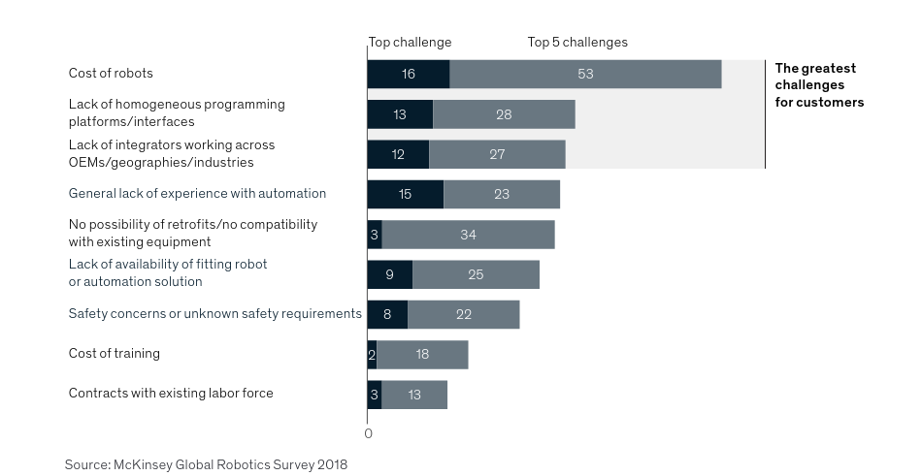Understanding, or rather grasping, robotics simulation and programming entails much more than just programming software. It involves navigating your way through an impossible mess of information leading to a rabbit hole of trying to synthesise “the disparate fields of robotic theory and software engineering while simultaneously accounting for a large variability in hardware designs and control paradigm” [1]. The trends depicted on page 24 in [3, Fig. 1] shown below how lack of experience, second only to the cost of robots as a top challenge globally and part of top three challenges after cost of robots which also include additional challenges with standardisation in programming methods, contribute to the impossible mess of information and challenges faced by newcomers even at corporate level beyond the individual student.

Fig. 1

Moreover, most courses “lack the systematic coverage of the techniques involved in developing, deploying, and applying software to real hardware” [2]. These formidable challenges create what Coleman et al. describe as “barriers to entry” — “the time, effort, and knowledge that a new user must invest in the integration of a software component with an arbitrary robot” [1]. These substantial investments required can deter novices and slow down adoption of robotic technologies by corporations.

1.3 Problem definition

To reduce barriers to entry, foster accessibility and inclusivity in robotics, a comprehensive simulation of a pick-and-place robotic arm will be developed and will be accompanied by web documentation that not only gets users quickly set up but also illuminates highly unintuitive concepts like quaternions for precise 3D orientation representation, the motion planning algorithms used in MoveIt 2 within the ROS 2 framework, and software engineering principles used.

1.4 Aim

This project aims to streamline the grasping of diverse robotics disciplines by consolidating information, from disparate sources, required in one place and developing a simulation-based pick-and-place robotic arm.

1.5 Objectives

1. To apply the Test-A-Theory approach to evaluate and enhance theoretical concepts presented by Moveit 2 Humble by simulating the autonomously picking up and placing of objects in designated locations by the Panda robot for novices.
2. To provide a comprehensive online documentation that extends and further explains important concepts missing from the Moveit 2 Humble’s documentation such as how quartenions are used for orientations, the motion planning algorithms and the software engineering principles.

1.6 Limitations

1. The accuracy of the robotic arm's simulated movements may be limited by the capabilities of the MoveIt 2 Humble framework and the Panda robot model.
2. The performance of the simulated robotic arm may not fully replicate real-world behaviors due to hardware variations.
3. The project timeline may restrict the depth of exploration into advanced motion planning algorithms.

1.7 Delimitations

1. Focus will be on simulating the Panda robotic arm's pick-and-place tasks within the MoveIt 2 Humble environment, excluding physical hardware implementation.
2. Emphasis will be placed on understanding and documenting quaternions for orientation representation, motion planning algorithms, and software engineering principles relevant to robotic simulations.
3. Documentation and tutorials will be tailored for beginners in robotics and software engineering, omitting advanced topics beyond this scope.

1.8 Development Instruments

1. Simulation Software:
2. MoveIt 2 Humble
3. ROS 2
4. RViz
5. Programming Languages:
6. C++
7. Python
8. Documentation :
9. HTML
10. CSS
11. Vanilla JavaScript
12. Version Control:
13. Git
14. GitHub

1.9 Work Plan

1. March:
2. *Week 1-2:* Set up the development environment — ROS 2 Humble and MoveIt 2 in a virtual environment. Familiarize with the Panda robot model and existing MoveIt 2 documentation.
3. *Week 3-4:* Develop basic simulation scenarios for the Panda robot's pick-and-place operations. Identify gaps or areas for improvement in current documentation.
4. April:
5. *Week 1-2:* Enhance simulation by refining code structure.
6. *Week 3-4:* Begin developing the website, focusing on structure, navigation, and initial content related to foundational concepts in robotics and software engineering.
7. May:
8. *Week 1-2:* Integrate advanced topics into the website, such as quaternions for orientations and detailed explanations of motion planning algorithms.
9. *Week 3-4:* Conduct thorough testing of simulations and the website. Gather feedback from supervisor and make necessary revisions. Prepare final documentation and project presentation.

1.10 Justification / Rationale

The proposed project addresses a critical need in the robotics community by developing accessible simulations and comprehensive documentation for the Panda robot using MoveIt 2.

This initiative aims to lower entry barriers for beginners, fostering a more inclusive learning environment and promoting innovation in the field.

By providing clear, practical examples and explanations, the project seeks to bridge the gap between theoretical knowledge and practical application, empowering a broader audience to engage with and contribute to robotics advancements.

1.11 Summary

Chapter 1 introduced the research problem, objectives, and scope.

Chapter 2 will delve into the planning phase, discussing the business value of the proposed system and conducting comprehensive feasibility analyses.

Chapter 3 will focus on the analysis phase, employing various information-gathering methodologies to scrutinize the existing system, identify its weaknesses, and define the functional and non-functional requirements for the new system.

Chapter 4 will then present the design phase, outlining the architectural and system designs, including context and data flow diagrams, class and sequence diagrams, database and interface designs, security considerations, and pseudocode for main functionalities.

Finally, Chapter 5 covers the implementation phase, detailing coding practices, testing procedures, installation processes, system changeover strategies, maintenance plans, and offering recommendations for deployment, updates, user support, and future work, concluding with reflections on the project's outcomes.

1.12 References

[1] D. Coleman, I. Şucan, S. Chitta, and N. Correll, "Reducing the Barrier to Entry of Complex Robotic Software: a MoveIt! Case Study," arXiv:1404.3785 [cs.RO], Apr. 2014. [Online]. Available: <https://arxiv.org/pdf/1404.3785>

[2] M. Möller, R. Jung, J. Betz, L. Westhofen, and S. Reuter, "Teaching Autonomous Systems Hands-On: Leveraging Modular Small-Scale Hardware in the Robotics Classroom," arXiv:2209.11181 [cs.RO], Sep. 2022. [Online]. Available: <https://arxiv.org/pdf/2209.11181>

[3] McKinsey & Company, "Industrial Robotics: Insights into the Sector's Future Growth Dynamics," July 2019. [Online]. Available: <https://www.mckinsey.com/~/media/mckinsey/industries/advanced%20electronics/our%20insights/growth%20dynamics%20in%20industrial%20robotics/industrial-robotics-insights-into-the-sectors-future-growth-dynamics.pdf>. [Accessed: 06 March 2025].

[4] J. R. Wilson, "Academic Writing," [Online]. Available: <https://wilson.fas.harvard.edu/AcademicWriting>. [Accessed: 06 March 2025].